**BTech ECE - Quantum University - Batch 01 - Task 03 - Inference Mapping.**

# Cybersecurity Threats in Mobile Banking:

Mobile banking has revolutionized financial transactions, providing ease and accessibility. However, this convenience also introduces significant cybersecurity threats. Cybercriminals deploy advanced techniques to exploit vulnerabilities, making it essential for users and financial institutions to stay informed and proactive in security measures.

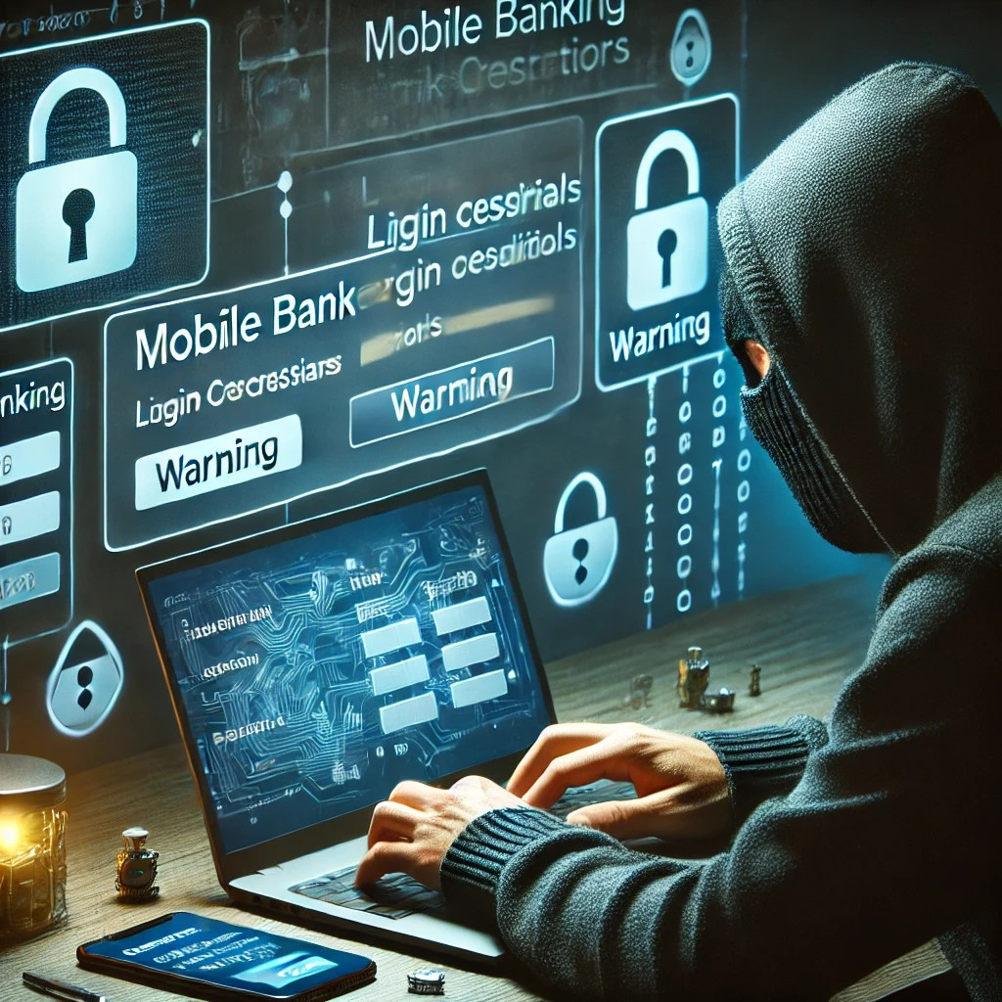

# Common Cybersecurity Threats:

## Trojans and Malware

Malicious software designed to steal login credentials and access banking apps.

## Phishing and Smishing

Fraudulent messages that trick users into revealing sensitive information.

## Man-in-the-Middle (MitM) Attacks

Hackers intercept communication between users and banks.

## Keylogging and Screen Logging

Malware records keystrokes or captures screen activity.

## Overlay Attack

Fake login screens trick users into entering their credentials.

## SIM Swaps

Cybercriminals hijack mobile numbers to intercept authentication codes.

## App Vulnerabilities

Weaknesses in banking apps that hackers can exploit.

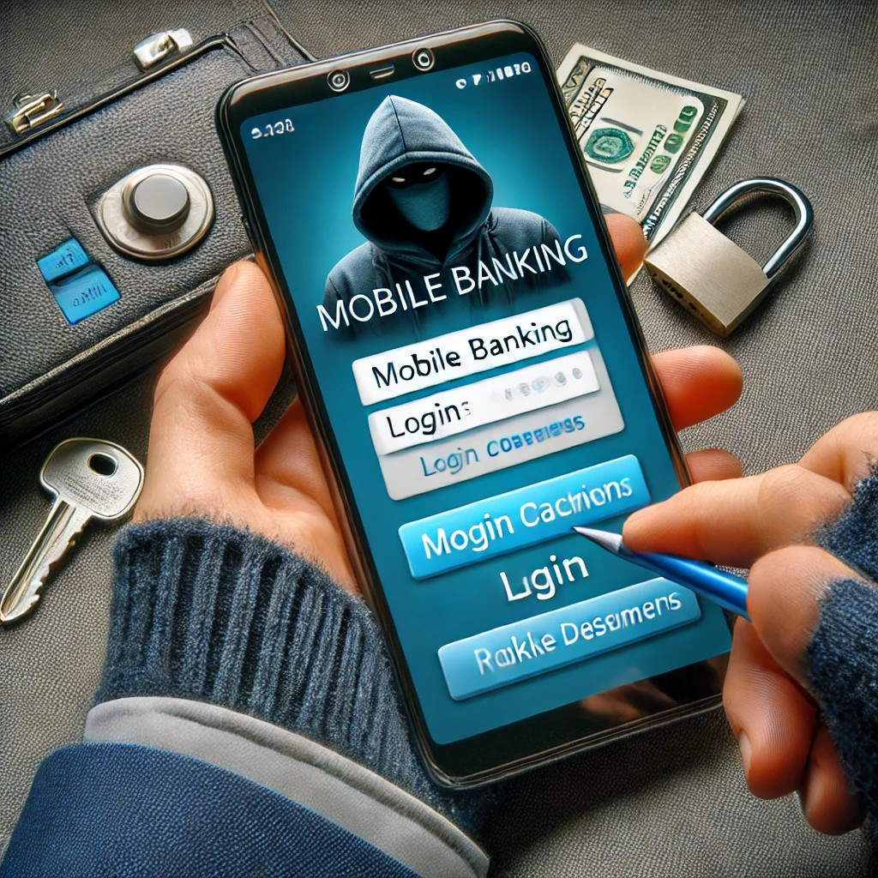

# Preventative Measures:

## For Users:

* + Download apps only from official stores.
  + Keep devices and apps updated.
  + Avoid clicking on suspicious links.
  + Use strong and unique passwords.
  + Enable Multi-Factor Authentication (MFA).
  + Monitor bank accounts regularly.

## For Financial Institutions:

* + Implement advanced encryption techniques.
  + Conduct regular security audits.
  + Educate users about potential risks.
  + Deploy fraud detection systems.

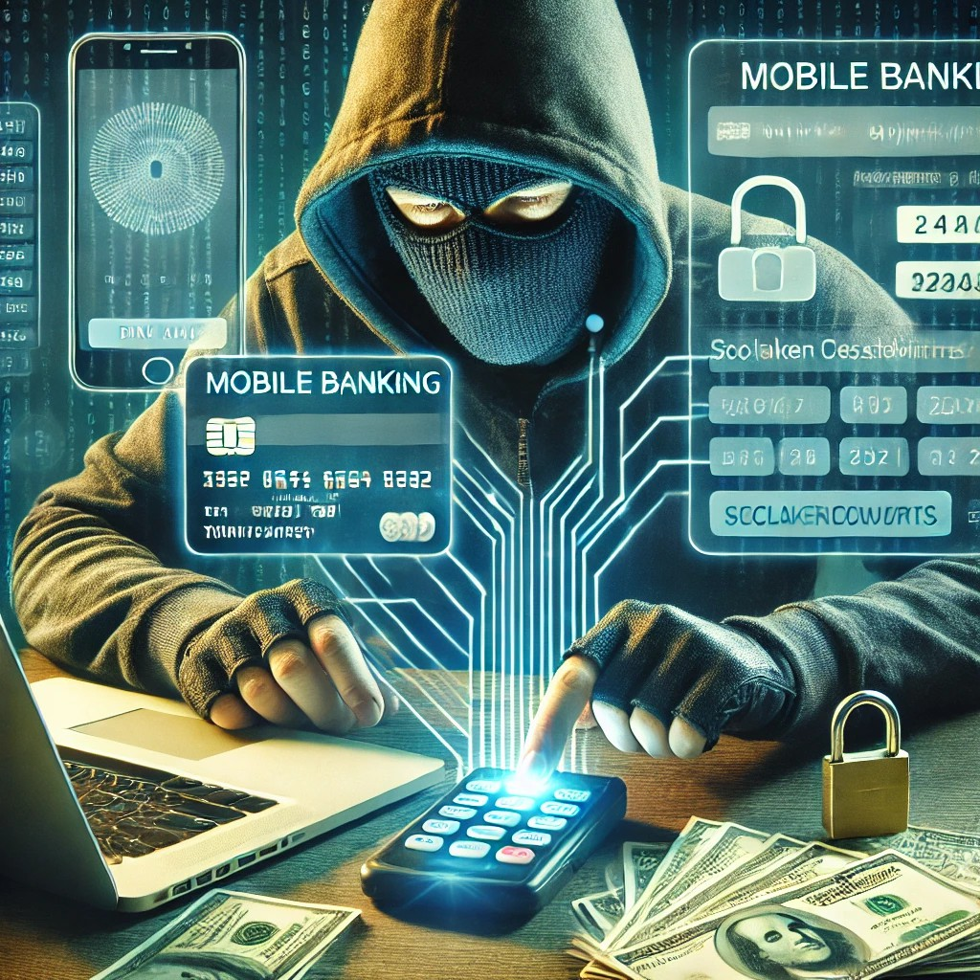

# References (Click to Open):

* [Symantec, 'Mobile Banking Threat Report', 2024](https://www.symantec.com/)
* [Kaspersky, 'Phishing and Mobile Banking Security', 2023](https://www.kaspersky.com/)
* [OWASP, 'Top 10 Mobile Security Risks', 2024](https://owasp.org/www-project-mobile-top-10/)
* [Cybersecurity & Infrastructure Security Agency (CISA), 'Best Practices for Mobile Banking', 2023](https://www.cisa.gov/)
* [McAfee, 'Emerging Threats in Mobile Financial Transactions', 2024](https://www.mcafee.com/)